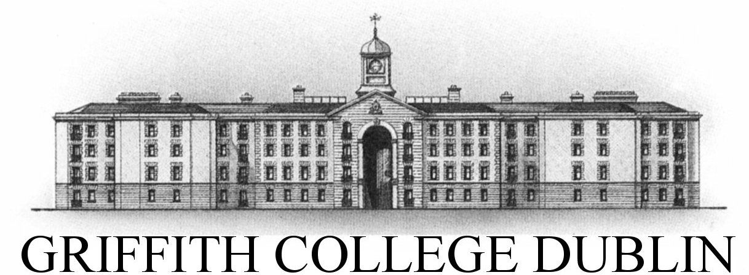
GRIFFITH COLLEGE LIMERICK

Software Development Project Cover Sheet

Student name: | Valentin Gnidyi
Student number: | 3054010
Faculty: | Engineering, Computing & IT
Course: | Bachelor of Science in Computing Science (Honours) Degree |  |  | Stage/year: | 4
Subject: | Software Development Project (SDP)
Study Mode: | Full time | X |  | Part-time
Lecturer Name: | Sonia Zheleva
Assignment Title: | Project Proposal
No. of pages:
No. of words:
Additional Information: | (i.e., number of pieces submitted, size of assignment, A2, A3 etc)
Date due: | 8.11.2023

Date submitted:
Plagiarism disclaimer:
I understand that plagiarism is a serious offence and have read and understood the college policy on plagiarism. I also understand that I may receive a mark of zero if I have not identified and properly attributed sources which have been used, referred to, or have in any way influenced the preparation of this assignment, or if I have knowingly allowed others to plagiarise my work in this way.

I hereby certify that this assignment is my own work, based on my personal study and/or research, and that I have acknowledged all material and sources used in its preparation. I also certify that the assignment has not previously been submitted for assessment and that I have not copied in part or whole or otherwise plagiarised the work of anyone else, including other students.
Signed: _____________________ Date: _____________

